**ICP-BRM Exception - Daily List Report**

**(JAVA Program)**

***By azha***

Program details

1. The program will be executed every day on 7 AM by cron job.
2. Program detail as below
   1. Server : ***Staging node 1***
   2. IP : ***10.41.66.24***
   3. Path : ***/home/S53725/icpException/***
   4. Program Name : ***mainProgram.sh***
   5. Jar file : ***IcpBRM_test.jar***
   6. Direct Path : ***/home/S53725/icpException/mainProgram.sh***
3. The program trigger all below database
   1. Siebel
   2. OSM
   3. EAI
   4. BRM
4. The program will sent email with 3 attachments after it finish run
   1. ***OSM_List.txt***
   2. ***ListFinal.txt***
   3. ***fileOutSBL.txt***

Step to produce daily report

1. Get previous day exception report first.
2. Copy yesterday list to the sheet **Yesterday List**
3. Open sheet **OSM List**
   1. Import data from text - file ***OSM_List.txt***

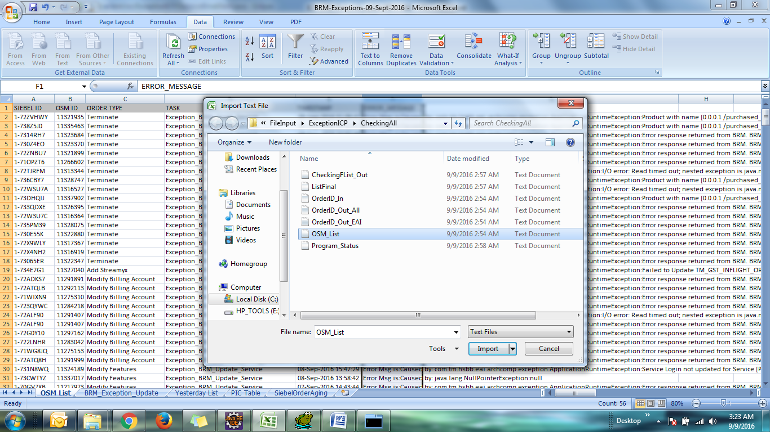

1. Open sheet **BRM_Exception_Update**
   1. Import data from text - file ***ListFinal.txt***

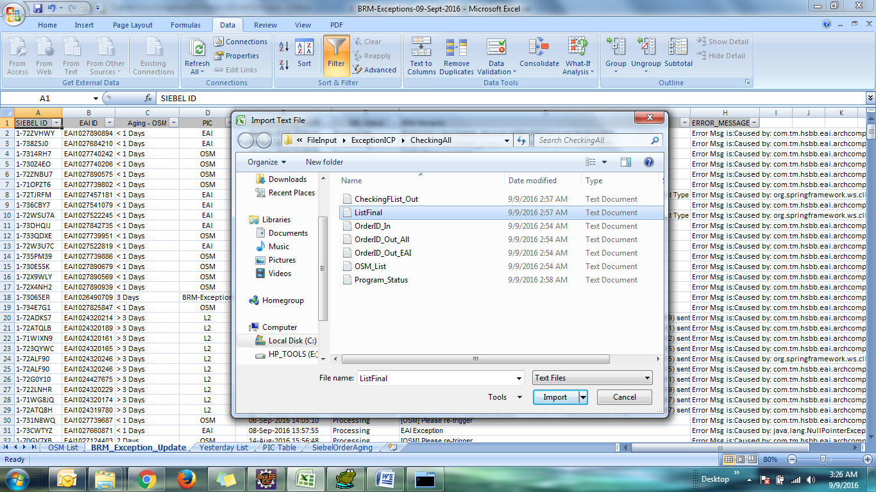

1. Open sheet **SiebelOrderAging**
   1. Click on column SBL, import data from text – file ***fileOutSBL.txt***

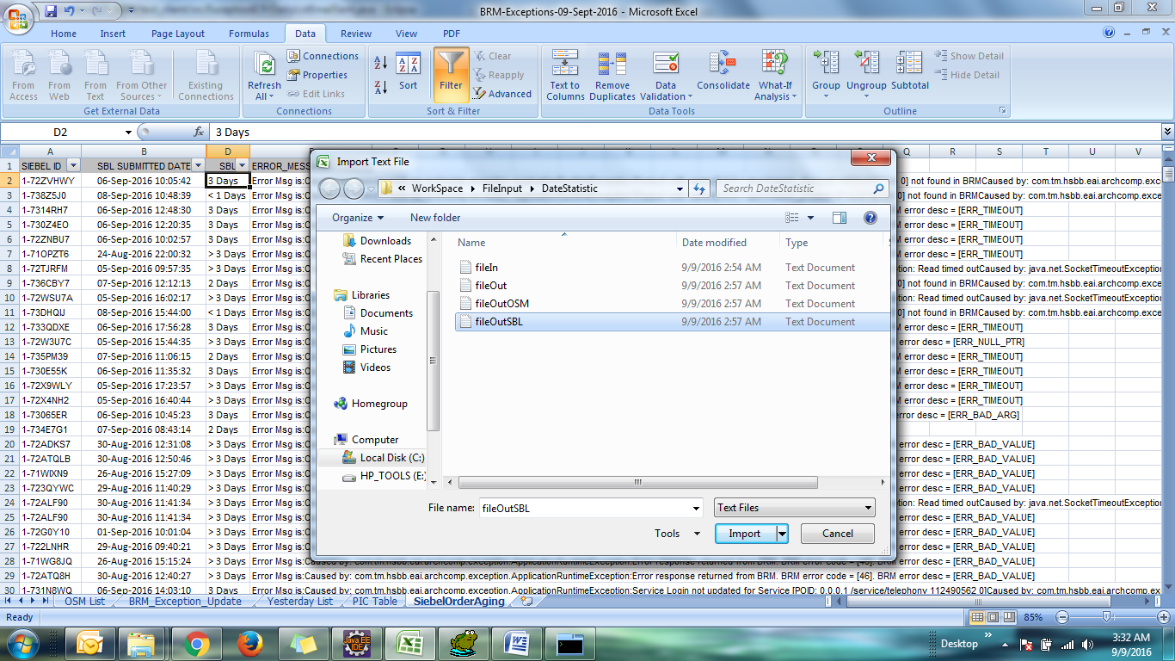

* 1. Then reselect/refresh other column and drag down because it refer to value on sheet **OSM List**

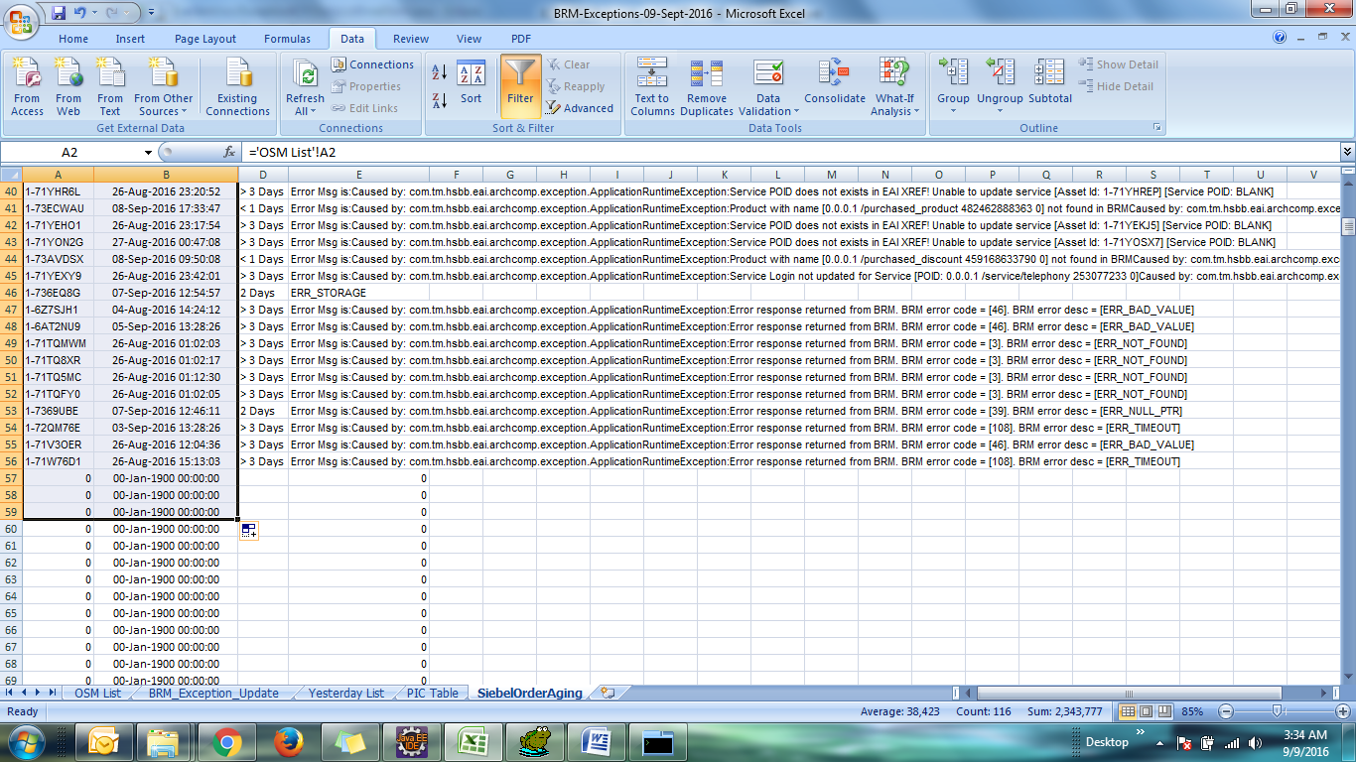

1. **PIC Table** sheet will update automatically.
2. Sheet **BRM_Exception_Update** – Null value under column PIC is where the request opcode not cater by my program. Its need to do testnap by BRM Exception team
3. To email the daily list, please open sheet **PIC Table**, copy the entire table and paste it inside the email. Then email all by attached together the exception excel file.